

PROJECT REPORT

ON

INTERVIEW ANALYSIS SYSTEM FACE DETECTION

Submitted in partial fulfillment of requirement for the award of the degree of
MASTER OF COMPUTER APPLICATIONS (SCHOOL OF COMPUTER APPLICATIONS) SESSION: 2026-2027

SUBMITTED BY:
Riya Kumari Bhagat (12515067)

SUPERVISED BY:
Mr. Sreesh Bhat U

LOVELY PROFESSIONAL UNIVERSITY, JALANDHAR, PUNJAB - 144411

CERTIFICATE

This is to certify that the project entitled "Interview Analysis with face detection has been successfully completed by Riya Kumari Bhagat, as a part of Summer PEP Cohort classes conducted during the academic session 2026-2027 at the School of Computer Applications, Lovely Professional University.
The work embodied in this project report is original and has been carried out under my supervision. To the best of my knowledge, this project has not been submitted, either in part or in full, to any other university or institution for the award of any degree or diploma.

Submitted By
Riya Kumari Bhagat (Registration No.: 12515067)

Project Guide
Mr. Sreesh Bhat U
Signature of Project Guide: ______________________
Date: ______________________
Place: Jalandhar, Punjab

DECLARATION
I, Riya Bhagat, hereby declare that the work done by me on “Interview Analysis with Face Detection” from Aug 2026 to July 2026 at Lovely Professional University, Phagwara, Punjab, is a record of original work carried out by me for the partial fulfillment of the requirements for Summer PEP Project
I further declare that this project has not been submitted, either in whole or in part, to any other university or institution for the award of any degree, diploma, or any other academic qualification.
The information, data, and references used in this project have been acknowledged appropriately wherever required. I take full responsibility for the authenticity and originality of the work presented in this report.

Submitted By
Riya Kumari Bhagat
Master of Computer Applications (MCA)
Registration No.: 12515067
Date: ______________________

Signature of Student

ACKNOWLEDGEMENT
I would like to express my sincere gratitude to my project guide, Mr. Sreesh Bhat U , for providing valuable guidance, continuous encouragement, and constructive suggestions throughout the development of this project titled "Interview Analysis with Face Detection" Their support and expertise greatly contributed to the successful completion of this work.
I am deeply thankful to the Head of the Department of Computer Applications and all the faculty members of School of Computer Applications for providing the necessary facilities, resources, and academic support required for this project.
I would also like to thank my family and friends for their constant motivation, encouragement, and support throughout my academic journey. Their confidence in me inspired me to complete this project successfully.
Finally, I express my gratitude to everyone who directly or indirectly contributed to the successful completion of this project.

Submitted By
Riya Kumari Bhagat
Registration No.: 12515067

Date: ______________________

ABSTRACT
The Interview Analysis System Using Computer Vision and Facial Landmark Detection is a Python-based web application developed to analyze a candidate's interview performance using artificial intelligence and computer vision techniques. The system supports both pre-recorded interview videos and live webcam interview sessions, providing an automated and objective evaluation of non-verbal communication during interviews.
The application is developed using Python and Streamlit for the user interface. OpenCV is used for video frame processing, while MediaPipe Face Landmarker detects facial landmarks, facial blendshapes, and head transformation matrices. The system estimates the candidate's facial emotions based on facial blendshape scores and evaluates eye contact, attention, face visibility, and overall engagement throughout the interview.
The engagement score is calculated using a weighted scoring method, where eye contact contributes 40%, attention contributes 40%, and face visibility contributes 20% of the final score. The analyzed results are presented through interactive dashboards using Plotly, allowing users to understand their interview performance visually. The system also generates a downloadable JSON report containing detailed analysis results and performance metrics.
The proposed system provides an efficient, automated, and consistent approach for evaluating interview performance without requiring manual observation. It can assist candidates in identifying areas for improvement while helping organizations perform preliminary behavioral assessments. The project demonstrates the practical application of computer vision and facial landmark analysis in developing intelligent interview evaluation systems and provides a foundation for future enhancements such as speech analysis, transcript generation, deep learning-based emotion recognition, and comprehensive interview analytics.
Keywords: Computer Vision, Interview Analysis, MediaPipe Face Landmarker, Streamlit, OpenCV, Facial Landmarks, Emotion Estimation, Eye Contact Detection, Attention Analysis, Engagement Score.

TABLE OF CONTENTS

CERTIFICATE 2
DECLARATION 3
ACKNOWLEDGEMENT 4
ABSTRACT 5
CHAPTER 1: INTRODUCTION 8
1.1 Introduction 9
1.2 Problem Statement 10
1.3 Objectives 10
1.4 Scope of the Project 11
1.5 Applications of the Project 11
CHAPTER 2: EXISTING SYSTEM 13
2.1 Introduction 13
2.2 Existing System 13
2.3 Limitations of the Existing System 14
2.4 Need for the Proposed System 14
2.5 Comparison Between Existing System and Proposed System 15
CHAPTER 3: PROPOSED SYSTEM 16
3.1 Introduction 16
3.2 Proposed System 16
3.3 Technology Stack 17
Why These Technologies Were Chosen 17
3.4 System Architecture 18
3.5 Module Description 20
3.5.1 Video Input Module 20
3.5.2 Video Processing Module 20
3.5.3 Face Detection Module 20
3.5.4 Facial Landmark Extraction Module 20
3.5.5 Emotion Estimation Module 20
3.5.6 Eye Contact Detection Module 21
3.5.7 Attention Detection Module 21
3.5.8 Face Visibility Module 21
3.5.9 Engagement Score Module 21
3.5.10 Dashboard Module 21
3.5.11 Report Generation Module 21
3.6 Workflow 21
3.7 Scoring Logic 24
Eye Contact Score 24
Attention Score 24
Face Visibility Score 24
3.8 Implementation Details 24
3.9 Advantages of the Proposed System 25
CHAPTER 4: SYSTEM IMPLEMENTATION 26
4.1 Introduction 26
4.2 Project Directory Structure 26
Project Structure 26
Description of Project Files 27
4.3 Video Processing Module 28
Functions Performed by the Module 28
4.4 Face Detection Module 29
Functions Performed 29
4.5 Emotion Detection Module 30
Functions Performed 31
4.6 Eye Contact Detection Module 32
Functions Performed 32
4.7 Attention Detection Module 32
Functions Performed 33
4.8 Engagement Score Module 33
Functions Performed 34
4.9 Live Interview Processing Module 34
Functions Performed 34
4.10 Streamlit User Interface 35
4.11 Report Generation Module 36
4.12 Testing and Results 38
CHAPTER 5: RESULTS AND DISCUSSION 39
5.1 Introduction 39
5.2 Experimental Testing 39
5.3 Result Analysis 39
Table 5.1 Performance of System Modules 40
5.4 Discussion 40
5.5 Performance Evaluation 41
CHAPTER 6: CONCLUSION AND FUTURE SCOPE 42
6.1 Conclusion 42
6.2 Limitations 42
6.3 Future Scope 43
6.4 Overall Summary 43
BIBLIOGRAPHY 44
APPENDIX 45
Appendix A – Software Requirements 45
Appendix B – Hardware Requirements 45
Minimum Requirements 45
Recommended Requirements 45
Appendix C – Sample Output 45

CHAPTER 1: INTRODUCTION

1.1 Introduction
In today's competitive job market, interviews play a vital role in evaluating a candidate's technical knowledge, communication skills, confidence, and overall personality. While traditional interview assessments mainly rely on human observation, they can be subjective, time-consuming, and influenced by personal bias. Advances in Artificial Intelligence (AI) and Computer Vision have made it possible to automate parts of the interview evaluation process by analyzing a candidate's facial expressions, eye contact, head movements, and overall engagement.
The Interview Analysis System Using Computer Vision and Facial Landmark Detection is designed to provide an automated approach for evaluating a candidate's non-verbal behavior during an interview. The system analyzes both uploaded interview videos and live webcam interview sessions to estimate behavioral indicators that are commonly associated with interview performance.
The application is developed using Python and Streamlit, providing a simple and interactive web-based interface. OpenCV is used for reading and processing video frames, while MediaPipe Face Landmarker detects facial landmarks, facial blendshapes, and head transformation matrices from each frame. These facial features are further analyzed to estimate emotions, eye contact, attention, face visibility, and an overall engagement score.
Emotion estimation is performed using facial blendshape values such as smile intensity, eyebrow movement, jaw opening, eye widening, cheek squint, and upper lip movement. Attention is estimated using the head transformation matrix, which provides information about head orientation and movement. Eye contact is analyzed using facial landmarks around the eyes to determine whether the candidate is looking toward the camera. Face visibility measures the percentage of frames in which the candidate's face is successfully detected.
To provide an overall assessment, the system calculates an engagement score using a weighted scoring approach in which eye contact contributes 40%, attention contributes 40%, and face visibility contributes 20%. The results are displayed through interactive dashboards and summarized in a downloadable JSON report for further analysis.
The proposed system offers a fast, objective, and automated solution for interview performance analysis. It can be used by students, job seekers, educational institutions, and organizations to evaluate interview behavior and identify areas for improvement. The project demonstrates how computer vision technologies can enhance interview assessment by providing consistent and data-driven performance analysis.

1.2 Problem Statement
Interviews are an important part of the recruitment process because they help employers evaluate a candidate's knowledge, communication skills, confidence, and overall personality. In most organizations, this evaluation is carried out manually by interviewers. As a result, the assessment often depends on personal observation and judgment, which can vary from one interviewer to another. This makes the interview process subjective and sometimes inconsistent.
With the growing use of online interviews, recruiters are required to review a large number of recorded interview sessions. Watching each interview carefully to observe a candidate's facial expressions, eye contact, attentiveness, and body language is a time-consuming task. Moreover, candidates usually receive only the final result of the interview and rarely get detailed feedback about their performance or the areas they need to improve.
Although many interview platforms support video recording and online communication, they generally do not provide automatic analysis of a candidate's non-verbal behavior. Features such as emotion estimation, eye contact analysis, attention monitoring, and engagement measurement are either unavailable or limited in most existing systems.
To overcome these limitations, this project proposes an Interview Analysis System Using Computer Vision and Facial Landmark Detection. The system automatically analyzes both uploaded interview videos and live webcam sessions to evaluate a candidate's non-verbal behavior. It estimates facial emotions, eye contact, attention, face visibility, and overall engagement using computer vision techniques. By generating an objective performance report, the system helps candidates understand their strengths and areas for improvement while assisting recruiters in conducting a more consistent and efficient preliminary interview evaluation.

1.3 Objectives
The main objective of this project is to develop an intelligent interview analysis system that can automatically evaluate a candidate's non-verbal behavior during an interview using computer vision techniques. The system is designed to provide a simple, fast, and objective way of analyzing interview performance from both recorded videos and live webcam sessions.
The specific objectives of this project are as follows:
- To develop a web-based application using Python and Streamlit for interview analysis.
- To allow users to analyze both uploaded interview videos and live webcam interview sessions.
- To detect facial landmarks, facial blendshapes, and head pose using MediaPipe Face Landmarker.
- To estimate the candidate's facial emotions based on facial blendshape values.
- To analyze eye contact by tracking facial and eye landmarks.
- To estimate the candidate's attention level using head movement and head orientation.
- To measure face visibility throughout the interview to ensure consistent face detection.
- To calculate an overall engagement score using eye contact, attention, and face visibility.
- To display the analysis results through interactive charts and dashboards for easy understanding.
- To generate a downloadable JSON report containing the complete interview analysis and performance summary.
- To provide candidates with meaningful feedback that can help them improve their interview performance.
- To demonstrate the practical application of computer vision and facial landmark detection in automated interview assessment.

1.4 Scope of the Project
The scope of this project is to develop an intelligent interview analysis system that evaluates a candidate's non-verbal behavior during an interview using computer vision techniques. The system is designed to analyze both pre-recorded interview videos and live webcam interview sessions through a simple web-based interface.
The project focuses on analyzing facial expressions, eye contact, attention level, and face visibility by using MediaPipe Face Landmarker. Based on these observations, the system estimates the candidate's overall engagement during the interview. The analysis results are presented through interactive charts and are also provided as a downloadable JSON report for future reference.
The system can be used by students, job seekers, educational institutions, and organizations to understand interview performance in an objective manner. It can also serve as a practice tool for candidates who want to improve their confidence and communication before attending actual interviews.
However, the project is limited to the analysis of visual facial cues. It does not evaluate the candidate's spoken answers, voice quality, technical knowledge, or communication content. These features can be included in future versions of the system.

1.5 Applications of the Project
The Interview Analysis System has applications in various fields where interview performance assessment is important. It provides an automated and objective method for analyzing a candidate's non-verbal behavior and can be used for both learning and recruitment purposes.
Some major applications of the proposed system are as follows:
- Interview Practice: Candidates can use the system to practice interviews and receive feedback on their eye contact, attention, facial expressions, and overall engagement.
- Campus Placement Preparation: Colleges and universities can use the system to help students improve their interview skills before placement drives.
- Recruitment Process: Organizations can use the system as a preliminary interview assessment tool to analyze candidate behavior during recorded or live interviews.
- Online Interview Platforms: The system can be integrated into virtual interview platforms to provide automated behavioral analysis.
- Training and Skill Development: Training institutes and career development centers can use the system to monitor the progress of students and provide personalized guidance.
- Research in Computer Vision: The project can also be used as a learning and research platform for studying facial landmark detection, emotion estimation, and human behavior analysis using computer vision technologies.
Overall, the proposed system offers a practical solution for improving interview preparation and supporting objective behavioral assessment in modern recruitment environments.

CHAPTER 2: EXISTING SYSTEM

2.1 Introduction
With the rapid growth of online recruitment and virtual interviews, many organizations have adopted digital platforms for conducting interviews. These platforms make the recruitment process more convenient by allowing candidates to attend interviews from any location. However, most existing interview systems primarily focus on video communication and recording, offering very limited support for analyzing a candidate's non-verbal behavior.
Some interview platforms provide features such as video recording, scheduling, resume management, and basic interview tracking. While these features simplify the recruitment process, they still rely heavily on human interviewers to evaluate facial expressions, eye contact, confidence, and attentiveness. This manual evaluation can be subjective and may vary depending on the interviewer's experience and judgment.
In recent years, computer vision and artificial intelligence have introduced new possibilities for automated interview assessment. Technologies such as facial landmark detection and facial expression analysis can help estimate a candidate's emotional state and level of engagement. However, many existing solutions are either commercial products with limited accessibility or research-based systems that focus on only one aspect of interview analysis, such as emotion recognition or eye tracking.
These limitations create the need for a system that can combine multiple behavioral indicators into a single platform. The proposed Interview Analysis System addresses this need by integrating emotion estimation, eye contact analysis, attention monitoring, face visibility detection, and engagement scoring within an easy-to-use web application. This approach provides users with meaningful feedback while reducing the dependency on manual observation.

2.2 Existing System
The existing interview process is mainly conducted through face-to-face interactions or online interview platforms such as video conferencing applications. In both cases, the candidate's performance is evaluated by human interviewers based on their technical knowledge, communication skills, confidence, and overall behavior. Although this method has been widely used for many years, it depends largely on the interviewer's personal observation and experience.
Several online interview platforms allow recruiters to record interview sessions, schedule interviews, and manage candidate information. Some advanced platforms also provide features such as resume screening, interview recording, speech transcription, and AI-based question generation. However, most of these systems do not provide a detailed analysis of a candidate's non-verbal behavior during the interview.
Research-based interview analysis systems have attempted to use artificial intelligence and computer vision for emotion recognition or eye tracking. However, many of these systems focus on a single feature and do not provide a complete evaluation of candidate engagement. Some solutions also require expensive software, specialized hardware, or trained deep learning models, making them difficult to implement in educational institutions or small organizations.
As a result, there is still a need for a simple, cost-effective, and user-friendly system that can automatically analyze multiple aspects of interview behavior and generate meaningful performance reports.

2.3 Limitations of the Existing System
The existing interview systems have several limitations that reduce the effectiveness of candidate evaluation. Some of the major limitations are listed below:
- Interview evaluation is mainly based on the personal observation and judgment of the interviewer, which may lead to biased or inconsistent results.
- Reviewing recorded interview videos manually requires considerable time and effort, especially when a large number of candidates need to be assessed.
- Most online interview platforms focus only on conducting interviews and recording videos without providing automatic behavioral analysis.
- Existing systems generally do not measure important non-verbal factors such as eye contact, attention level, face visibility, and overall engagement.
- Candidates usually receive only the interview result and do not get detailed feedback that can help them improve their interview performance.
- Many AI-based interview analysis solutions are commercial products that require paid subscriptions or specialized resources, making them less accessible for educational institutions and small organizations.
- Some research-based systems analyze only a single parameter, such as emotion recognition or gaze estimation, instead of providing a complete behavioral assessment.
These limitations highlight the need for an automated interview analysis system that can objectively evaluate multiple behavioral factors and provide meaningful feedback through an easy-to-use and affordable platform.

2.4 Need for the Proposed System
The increasing use of online interviews has created a demand for tools that can evaluate candidates more efficiently and objectively. Recruiters often have to assess a large number of interview recordings, making the evaluation process time-consuming and challenging. Since human assessment can vary from one interviewer to another, there is a need for a system that provides consistent and unbiased analysis.
The proposed Interview Analysis System addresses these challenges by automatically analyzing a candidate's non-verbal behavior during an interview. Instead of relying only on manual observation, the system uses computer vision techniques to estimate facial emotions, eye contact, attention level, face visibility, and overall engagement.
The system also provides instant feedback through interactive dashboards and a downloadable report, allowing candidates to understand their strengths and identify areas for improvement. Since the application is developed using open-source technologies such as Python, Streamlit, OpenCV, and MediaPipe, it is affordable, easy to use, and can be deployed without specialized hardware.
Overall, the proposed system aims to make interview analysis more efficient, objective, and accessible for both candidates and organizations.

2.5 Comparison Between Existing System and Proposed System
Existing System | Proposed System
Interview evaluation is performed manually by interviewers. | Interview performance is analyzed automatically using computer vision techniques.
Assessment depends on the interviewer's observation and may be subjective. | The system provides a more objective and consistent evaluation based on facial analysis.
Most platforms only record interviews without detailed behavioral analysis. | The system analyzes emotions, eye contact, attention, face visibility, and engagement.
Reviewing recorded interviews takes significant time and effort. | The analysis is performed automatically, reducing manual effort.
Candidates usually receive limited feedback after the interview. | Candidates receive detailed performance insights through dashboards and downloadable reports.
Existing solutions may require expensive software or paid services. | The system is built using open-source technologies, making it cost-effective and easy to use.
Most systems focus on a single feature or provide basic interview management. | The proposed system combines multiple behavioral indicators into a single platform for comprehensive interview analysis.

CHAPTER 3: PROPOSED SYSTEM

3.1 Introduction
The proposed Interview Analysis System Using Computer Vision and Facial Landmark Detection is developed to provide an automated and objective method for analyzing a candidate's interview performance. Unlike traditional interview evaluation, which mainly depends on the observation of the interviewer, the proposed system uses computer vision techniques to analyze a candidate's non-verbal behavior during an interview.
The system supports two modes of operation. The first mode allows users to upload a recorded interview video, while the second mode enables real-time analysis through a live webcam. In both cases, the system processes the video frame by frame and extracts facial information using MediaPipe Face Landmarker.
The extracted facial landmarks, facial blendshapes, and head transformation matrix are used to estimate different behavioral parameters such as facial emotion, eye contact, attention level, face visibility, and overall engagement. After the analysis is completed, the results are presented through interactive dashboards and a downloadable report.
The proposed system is designed to provide consistent, fast, and reliable interview analysis while reducing the dependency on manual observation. It also helps candidates understand their interview performance and identify areas where they can improve.

3.2 Proposed System
The proposed system is a web-based application developed using Python and Streamlit. It combines computer vision techniques with facial landmark detection to evaluate a candidate's behavior during an interview.
The system accepts either a pre-recorded interview video or a live webcam stream as input. Once the input is received, the video is processed frame by frame using OpenCV. Each frame is passed to the MediaPipe Face Landmarker model, which detects the candidate's face and extracts facial landmarks, facial blendshapes, and the head transformation matrix.
The extracted facial information is then used for different analyses. Facial blendshape values help estimate the candidate's facial emotion. Eye landmarks are analyzed to estimate eye contact with the camera. The head transformation matrix is used to estimate the candidate's attention level by measuring head orientation. At the same time, the system keeps track of face visibility throughout the interview.
After processing all frames, the system calculates an overall engagement score using eye contact, attention, and face visibility. The final results are displayed through interactive dashboards, allowing users to understand their performance visually. A detailed interview report is also generated in JSON format, which can be downloaded for future reference.
The proposed system provides an efficient and user-friendly solution for interview analysis without requiring expensive hardware or complex software installation.

3.3 Technology Stack
The development of the Interview Analysis System involves several open-source technologies that work together to perform video processing, facial analysis, data visualization, and report generation.
Technology | Purpose
Python | Primary programming language used for developing the complete application.
Streamlit | Provides the web-based user interface for uploading videos, performing live analysis, and displaying results.
OpenCV | Reads videos, extracts frames, and performs image processing operations.
MediaPipe Face Landmarker | Detects facial landmarks, facial blendshapes, and head transformation matrices for facial analysis.
streamlit-webrtc | Enables real-time webcam streaming and live interview analysis within the browser.
PyAV | Handles video frame processing during live streaming.
Pandas | Stores and processes frame-wise analysis data before generating reports.
Plotly | Creates interactive charts and dashboards for visualizing interview analysis results.
JSON | Stores and exports the final interview report in a structured format.
Visual Studio Code | Integrated Development Environment (IDE) used for project development.
Git & GitHub | Used for version control and project management.

Why These Technologies Were Chosen
- Python was selected because of its extensive support for computer vision and machine learning libraries.
- Streamlit simplifies the development of interactive web applications without requiring extensive frontend development.
- OpenCV provides efficient video processing and frame extraction capabilities.
- MediaPipe Face Landmarker offers fast and accurate facial landmark detection along with facial blendshape estimation and head pose information.
- streamlit-webrtc enables smooth browser-based live video streaming.
- Pandas helps organize and analyze frame-level data efficiently.
- Plotly provides attractive and interactive visualizations that improve the user experience.
- JSON offers a lightweight and structured format for storing analysis results, making reports easy to download and process further.
The combination of these technologies results in a lightweight, efficient, and user-friendly interview analysis system that can operate on standard computing devices without requiring specialized hardware.

3.4 System Architecture
The architecture of the proposed Interview Analysis System is designed in a modular manner so that each component performs a specific task independently while working together to produce the final interview analysis. The system accepts either a recorded interview video or a live webcam stream as input. The input is processed frame by frame to detect facial features and evaluate the candidate's non-verbal behavior.
Initially, the system receives the input video from the user. OpenCV extracts individual frames from uploaded videos, while streamlit-webrtc captures frames directly from the webcam during live interviews. Each frame is then passed to the MediaPipe Face Landmarker model for face detection.
If a face is detected, the model extracts facial landmarks, facial blendshapes, and the head transformation matrix. These outputs are further processed by different analysis modules. The facial blendshape values are used to estimate the candidate's facial emotion, the eye landmarks are analyzed to estimate eye contact, and the head transformation matrix is used to determine the attention level. The system also monitors whether the candidate's face remains visible throughout the interview.
After all frames have been analyzed, the individual results are combined to calculate the overall engagement score. Finally, the analysis is displayed through interactive dashboards, and a downloadable JSON report is generated for the user.

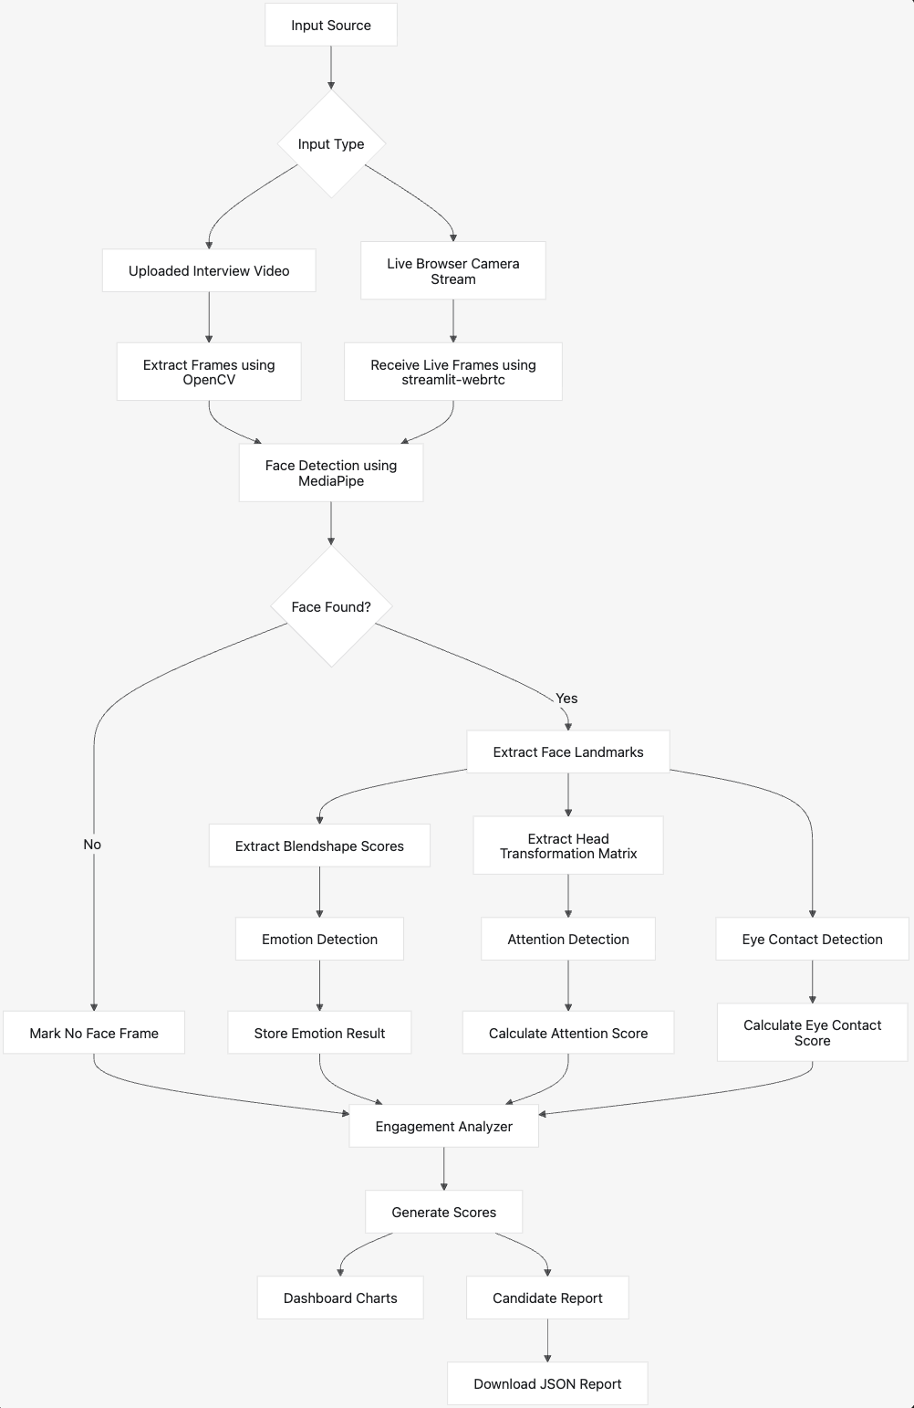
Figure 3.1: System Architecture Diagram

The above architecture illustrates the complete working of the proposed system. The process begins with either an uploaded interview video or a live webcam stream. The input is processed frame by frame using OpenCV or streamlit-webrtc. MediaPipe Face Landmarker detects the candidate's face and extracts facial landmarks, facial blendshape scores, and the head transformation matrix. These outputs are used to estimate emotion, attention, and eye contact. Finally, the engagement score is calculated, displayed on the dashboard, and included in the downloadable JSON report.

3.5 Module Description
The proposed system consists of several modules, each responsible for a specific task. Together, these modules perform the complete interview analysis process.

3.5.1 Video Input Module
This module accepts the interview input from the user. The user can either upload a recorded interview video or start a live interview using the webcam. The module validates the input before passing it to the processing stage.

3.5.2 Video Processing Module
The video processing module extracts frames from the uploaded video using OpenCV. During live interviews, frames are received continuously through streamlit-webrtc. These frames are then sent to the face detection module for further analysis.

3.5.3 Face Detection Module
This module uses MediaPipe Face Landmarker to detect the candidate's face in each frame. If no face is detected, the frame is marked as a "No Face" frame. If a face is detected, the system extracts detailed facial information required for further analysis.

3.5.4 Facial Landmark Extraction Module
Once the face is detected, this module extracts facial landmarks, facial blendshape scores, and the head transformation matrix. These outputs serve as the foundation for emotion estimation, eye contact analysis, and attention detection.

3.5.5 Emotion Estimation Module
This module estimates the candidate's facial emotion using MediaPipe facial blendshape values. Facial movements such as smiling, eyebrow movement, jaw opening, eye widening, cheek squint, and upper lip movement are analyzed to estimate emotions such as Happy, Neutral, Sad, Angry, Fear, Surprise, and Disgust.

3.5.6 Eye Contact Detection Module
The eye contact module analyzes facial landmarks around the eyes to determine whether the candidate is looking toward the camera. The percentage of frames with proper eye contact is calculated to generate the eye contact score.

3.5.7 Attention Detection Module
This module estimates the candidate's attention level using the head transformation matrix. The head rotation values along different axes help determine whether the candidate is focused on the interview or frequently looking away from the camera.

3.5.8 Face Visibility Module
The face visibility module calculates the percentage of frames in which the candidate's face is successfully detected. Continuous face visibility indicates proper camera positioning throughout the interview.

3.5.9 Engagement Score Module
This module combines the results obtained from eye contact, attention, and face visibility to calculate the final engagement score. The weighted scoring approach provides a single value that represents the candidate's overall level of engagement during the interview.

3.5.10 Dashboard Module
The dashboard module presents the interview analysis through interactive charts and graphs using Plotly. It allows users to easily understand their performance and compare different behavioral metrics.

3.5.11 Report Generation Module
After the analysis is complete, this module generates a detailed JSON report containing the candidate's interview statistics, emotion analysis, engagement score, eye contact score, attention score, and other performance metrics. The report can be downloaded for future reference.

3.6 Workflow
The working of the proposed system follows a sequence of steps from video input to report generation.
Uploaded Video Workflow
1. User uploads an interview video.
2. The system saves the video temporarily.
3. OpenCV reads the video file.
4. Frames are extracted from the video.
5. Each frame is sent to MediaPipe Face Landmarker.
6. If a face is detected, landmarks and blendshapes are extracted.
7. Emotion is detected using blendshape scores.
8. Eye contact is estimated using eye landmarks.
9. Attention is estimated using head pose values.
10. Engagement score is calculated.
11. Dashboard and candidate report are generated.
Live Interview Workflow
1. User selects Live Interview.
2. User starts the browser camera.
3. streamlit-webrtc receives live video frames.
4. Frames are passed to the live processor.
5. MediaPipe analyzes facial landmarks and blendshapes.
6. Live overlay displays face status, emotion, and engagement.
7. User clicks Generate Live Report.
8. Final report is generated from analyzed live frames.

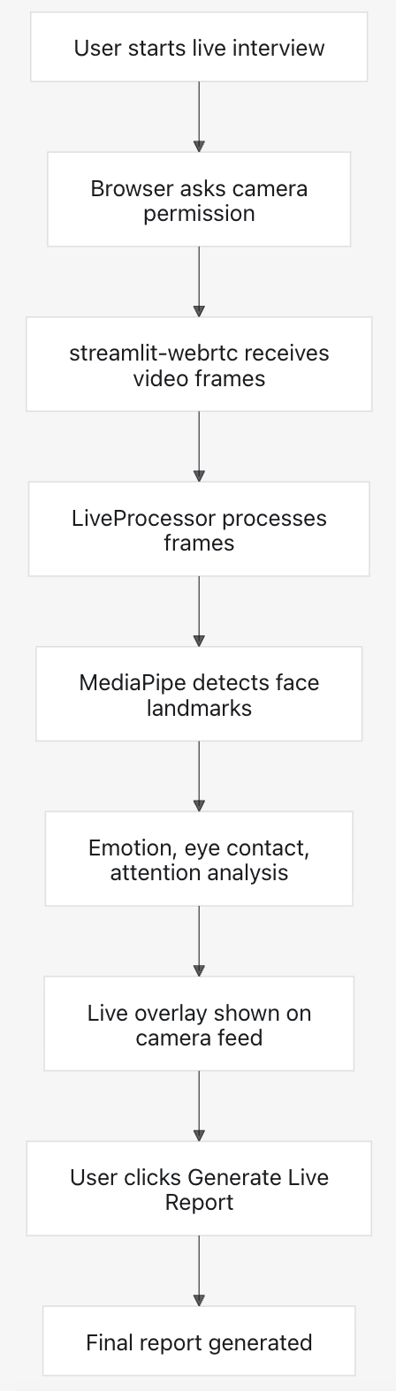
Figure 3.2: Live Interview Workflow

3.7 Scoring Logic
The proposed system evaluates a candidate's interview performance by calculating an Engagement Score, which represents the candidate's overall level of attentiveness and participation during the interview. Instead of relying on a single parameter, the system combines multiple behavioral indicators to produce a more balanced and reliable evaluation.
The engagement score is calculated using three important parameters:
- Eye Contact Score (40%)
- Attention Score (40%)
- Face Visibility Score (20%)
The engagement score is calculated using the following formula:
Engagement Score = (0.4 × Eye Contact Score) + (0.4 × Attention Score) + (0.2 × Face Visibility Score)

Eye Contact Score
Eye contact is estimated by analyzing the facial landmarks around the eyes. The system checks whether the candidate is looking toward the camera during the interview. A higher eye contact score indicates that the candidate maintained better visual interaction throughout the interview.

Attention Score
The attention score is estimated using the head transformation matrix generated by MediaPipe Face Landmarker. The head rotation values are analyzed to determine whether the candidate remains focused on the interview or frequently looks away from the camera.

Face Visibility Score
Face visibility measures the percentage of video frames in which the candidate's face is successfully detected. Continuous face visibility ensures that the interview can be analyzed accurately without interruptions caused by the candidate moving out of the camera view.
By combining these three parameters, the system provides an overall engagement score that represents the candidate's non-verbal participation during the interview.

3.8 Implementation Details
The Interview Analysis System is developed using Python and follows a modular implementation approach. Each module performs a specific task independently, making the application easier to understand, maintain, and extend.
The user interacts with the system through a web interface developed using Streamlit. The application allows users to upload an interview video or start a live interview session using their webcam.
For uploaded videos, OpenCV reads the video file and extracts individual frames. During live interviews, streamlit-webrtc captures frames continuously from the webcam. Each frame is processed using MediaPipe Face Landmarker, which detects facial landmarks, facial blendshape scores, and the head transformation matrix.
The extracted facial data is analyzed to estimate emotions, eye contact, attention level, and face visibility. These values are stored using Pandas, allowing frame-wise analysis throughout the interview.
After all frames have been processed, the system calculates the engagement score based on the predefined scoring formula. The results are then displayed using interactive Plotly charts, making it easy for users to understand their interview performance.
Finally, the application generates a structured JSON report containing detailed analysis results, including emotion distribution, eye contact score, attention score, face visibility, engagement score, and interview statistics. The report can be downloaded for future reference or further analysis.

3.9 Advantages of the Proposed System
The proposed Interview Analysis System offers several advantages over conventional interview evaluation methods.
- It provides an automated method for analyzing interview performance, reducing the need for manual observation.
- The system performs objective analysis based on computer vision techniques, minimizing personal bias during evaluation.
- It supports both uploaded interview videos and live webcam interviews within a single application.
- Multiple behavioral parameters, including facial emotions, eye contact, attention level, and face visibility, are analyzed simultaneously.
- Interactive dashboards help users understand their interview performance through graphical visualizations.
- The application is built entirely using open-source technologies, making it affordable and accessible for educational institutions, students, and organizations.
- The modular design allows new features to be added easily without modifying the complete system.
- The system can be used for interview preparation, campus placement training, recruitment support, and research in computer vision.

CHAPTER 4: SYSTEM IMPLEMENTATION

4.1 Introduction
This chapter explains the implementation of the proposed Interview Analysis System Using Computer Vision and Facial Landmark Detection. The system is developed using Python and follows a modular approach, where each module is responsible for a specific task. This design makes the application easier to understand, maintain, and extend with additional features in the future.
The application provides two modes of interview analysis. Users can either upload a recorded interview video or analyze their performance in real time using the webcam. After receiving the input, the system processes the video frame by frame, detects facial landmarks, estimates behavioral parameters, calculates an engagement score, and finally generates a detailed interview report.
The implementation uses several open-source technologies, including OpenCV for video processing, MediaPipe Face Landmarker for facial analysis, Streamlit for the user interface, Plotly for data visualization, and JSON for report generation. Each component works together to perform accurate and efficient interview analysis.

4.2 Project Directory Structure
The project is organized into multiple folders and Python modules. Each file is responsible for a specific functionality, making the source code modular, reusable, and easy to maintain.

Project Structure
Interview Analysis/
│
├── app.py
├── requirements.txt
├── README.md
│
├── model/
│ ├── face_landmarker.task
│
├── modules/
│ ├── __init__.py
│ ├── video_processor.py
│ ├── face_detector.py
│ ├── emotion_detector.py
│ ├── engagement.py
│ ├── report_generator.py
│ └── live_processor.py
│
└── test files

Description of Project Files

File / Folder | Description
app.py | Main application file that creates the Streamlit interface and controls the complete interview analysis process.
modules/video_processor.py | Reads the uploaded interview video, extracts video information, and processes individual frames.
modules/face_detector.py | Detects faces using MediaPipe Face Landmarker and extracts facial landmarks, blendshape scores, and head transformation matrices.
modules/emotion_detector.py | Estimates facial emotions using facial blendshape values obtained from MediaPipe.
modules/engagement.py | Calculates eye contact, attention, face visibility, and the final engagement score.
modules/report_generator.py | Generates the final interview analysis report in JSON format.
modules/live_processor.py | Processes live webcam frames for real-time interview analysis.
model/ | Contains the MediaPipe Face Landmarker model and other project resources.

4.3 Video Processing Module
The Video Processing Module is responsible for reading the uploaded interview video and preparing it for analysis. This functionality is implemented in the video_processor.py file.
When a user uploads an interview video through the Streamlit interface, the module first checks whether the video can be opened successfully. After validating the file, it reads important information such as the frame rate (FPS), total number of frames, video duration, frame width, and frame height.
Once the video information is obtained, the module processes the video frame by frame using OpenCV. Each extracted frame is forwarded to the Face Detection Module for further analysis. Processing every frame individually allows the system to monitor the candidate's behavior throughout the interview instead of analyzing only selected frames.
The module also handles invalid or corrupted video files. If the uploaded video cannot be opened, the system displays an appropriate error message and stops further processing, preventing unnecessary execution of the remaining modules.
The implementation is designed to work efficiently with different video lengths while maintaining smooth frame extraction and consistent performance.

Functions Performed by the Module
- Opens the uploaded interview video.
- Validates whether the video file is readable.
- Extracts video properties such as FPS, duration, width, and height.
- Reads the video frame by frame.
- Sends each frame to the Face Detection Module.
- Handles errors related to invalid or unsupported video files.
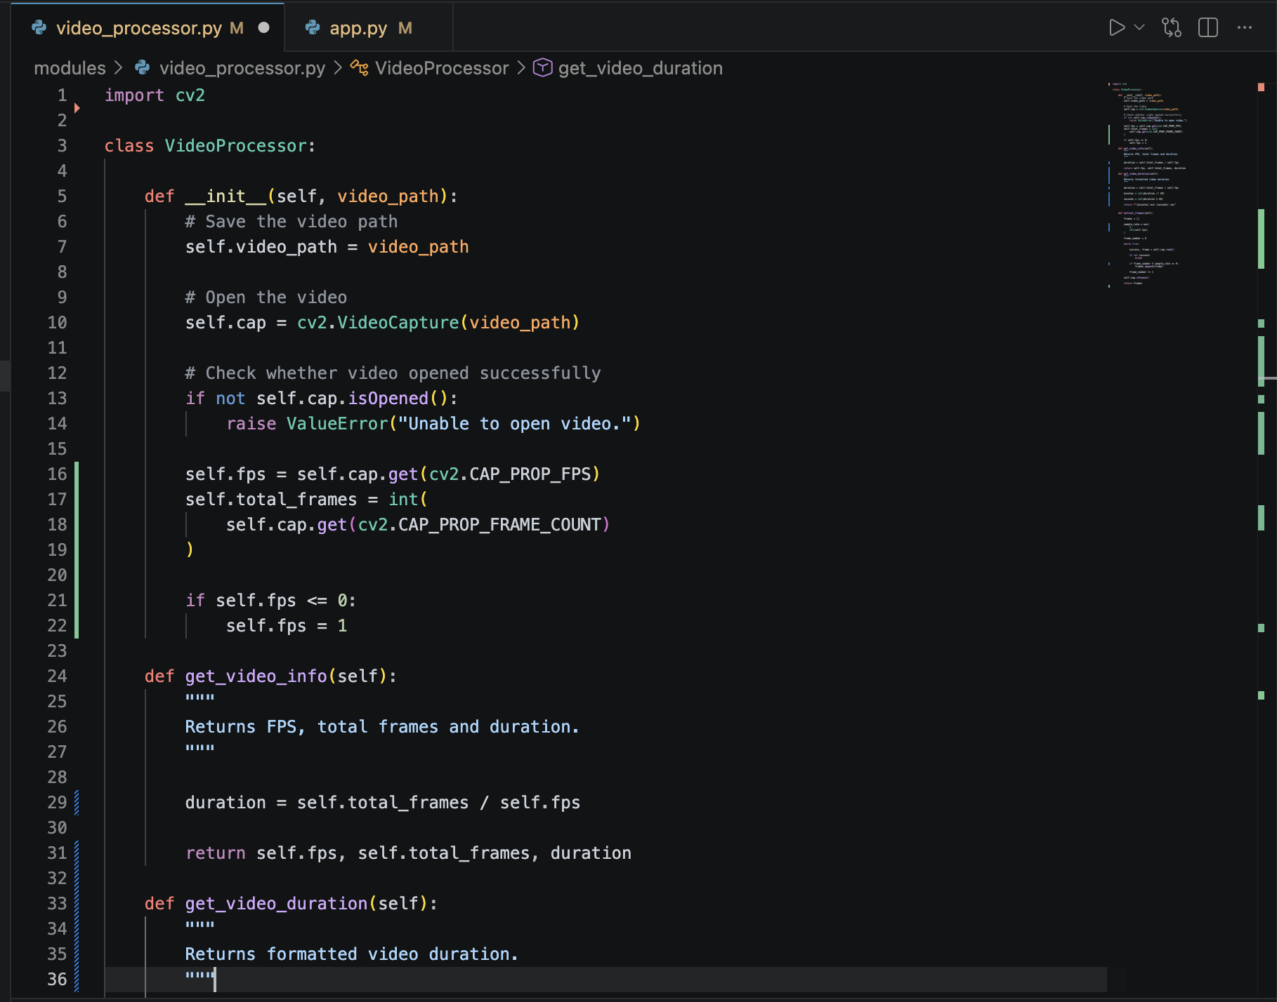
Figure 4.1: Video Upload and Processing Flow

4.4 Face Detection Module
The Face Detection Module is one of the most important components of the Interview Analysis System. It is responsible for detecting the candidate's face in every video frame and extracting the facial information required for further analysis.
This module is implemented in the face_detector.py file using MediaPipe Face Landmarker. For every frame received from the Video Processing Module, the system checks whether a face is present. If a face is detected successfully, MediaPipe extracts three important outputs:
- Facial Landmarks
- Facial Blendshape Scores
- Head Transformation Matrix
These outputs provide the information required to estimate emotions, eye contact, and attention during the interview.
If no face is detected in a frame, the system marks it as a "No Face Detected" frame. This information is later used while calculating the Face Visibility Score.
The Face Detection Module works efficiently in both uploaded interview videos and live webcam sessions, making it suitable for real-time interview analysis.

Functions Performed
- Detects the candidate's face.
- Extracts facial landmarks.
- Extracts facial blendshape scores.
- Extracts the head transformation matrix.
- Detects frames where no face is visible.
- Sends extracted data to the analysis modules.

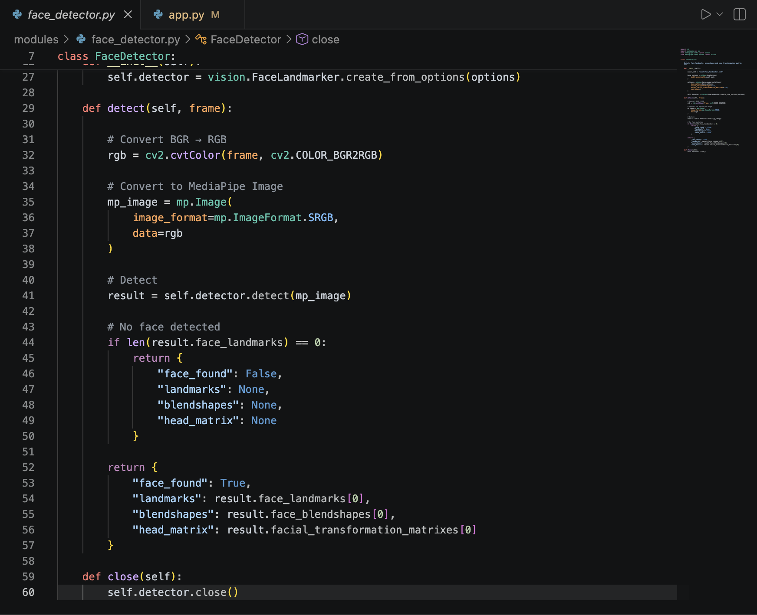
Figure 4.2: Face Detection Using MediaPipe Face Landmarker

4.5 Emotion Detection Module
The Emotion Detection Module estimates the candidate's facial emotion using the facial blendshape scores generated by MediaPipe Face Landmarker. Instead of using a separately trained deep learning model, the system analyzes facial movements represented by blendshape values to estimate the dominant facial expression.
Several facial movements contribute to emotion estimation, including:
- Smile intensity
- Eyebrow movement
- Jaw opening
- Eye widening
- Cheek squint
- Upper lip movement
- Nose movement
By analyzing the combination of these facial movements, the system estimates emotions such as:
- Happy
- Neutral
- Sad
- Angry
- Fear
- Surprise
- Disgust
The detected emotion for each frame is stored during processing. After the interview is completed, the system calculates the percentage of each detected emotion and displays the results using interactive charts.
This approach provides a lightweight and efficient solution because it directly uses MediaPipe's facial blendshape information without requiring a large emotion recognition dataset or additional model training.

Functions Performed
- Receives facial blendshape scores.
- Estimates the dominant facial emotion.
- Stores frame-wise emotion results.
- Calculates overall emotion distribution.
- Sends emotion statistics to the dashboard and report generator.
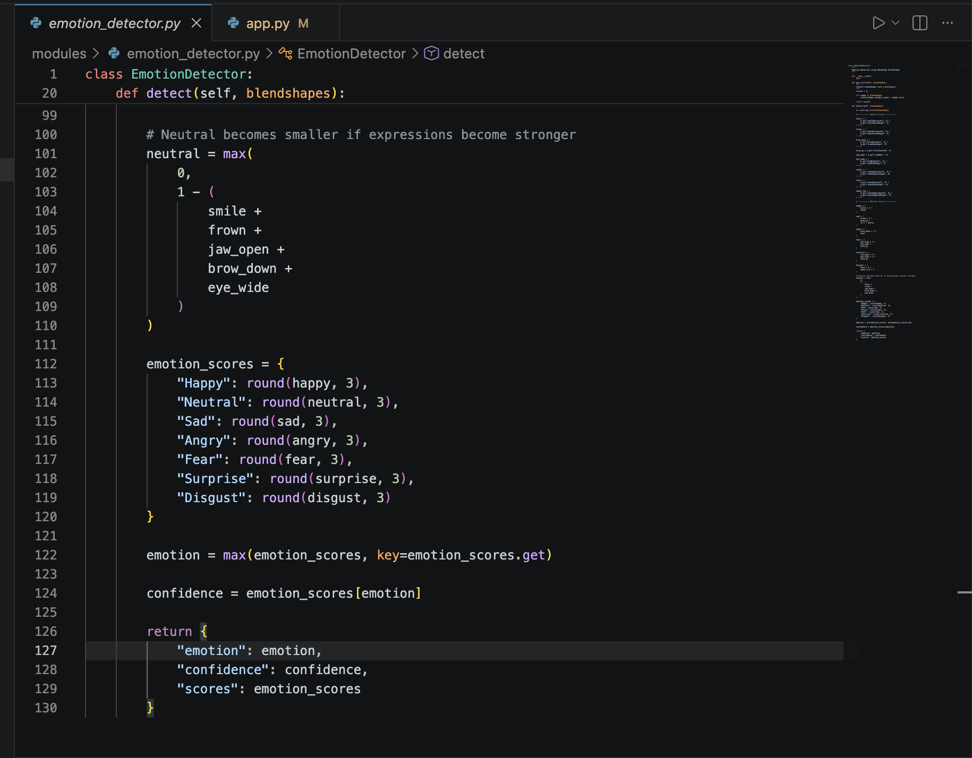
Figure 4.3: Emotion Detection Process

4.6 Eye Contact Detection Module
Eye contact is considered one of the most important non-verbal indicators during an interview. Candidates who maintain proper eye contact generally appear more confident, attentive, and engaged.
The Eye Contact Detection Module estimates whether the candidate is looking toward the camera by analyzing facial landmarks around the eyes together with the orientation of the detected face.
For every processed frame, the system determines whether eye contact is maintained. Frames where the candidate appears to be looking toward the camera are counted as positive eye-contact frames.
After the complete interview has been analyzed, the system calculates the Eye Contact Score as the percentage of frames in which proper eye contact was maintained.
The calculated score is later used as one of the major parameters while computing the final Engagement Score.

Functions Performed
- Detects eye landmark positions.
- Estimates whether the candidate is looking toward the camera.
- Counts eye-contact frames.
- Calculates the Eye Contact Score.
- Sends the score to the Engagement Module.

4.7 Attention Detection Module
The Attention Detection Module measures how focused the candidate remains during the interview. In a real interview, maintaining attention is an important aspect of professional communication. Frequent head movements or continuously looking away from the camera may indicate a lack of concentration or engagement.
This module uses the Head Transformation Matrix generated by MediaPipe Face Landmarker. The transformation matrix provides information about the orientation and rotation of the candidate's head in three-dimensional space. By analyzing these values for every video frame, the system determines whether the candidate is facing the camera or looking away.
During the interview, the module continuously monitors the head position and records the attention status for each frame. After all frames have been processed, the system calculates the overall Attention Score based on the percentage of frames in which the candidate remained attentive.
The calculated Attention Score is later combined with Eye Contact Score and Face Visibility Score to determine the final Engagement Score.

Functions Performed
- Receives the head transformation matrix from MediaPipe.
- Determines the direction of the candidate's head.
- Identifies attentive and non-attentive frames.
- Calculates the overall Attention Score.
- Sends the calculated score to the Engagement Module.

4.8 Engagement Score Module
The Engagement Score Module combines the results obtained from different analysis modules to provide an overall assessment of the candidate's interview performance. Instead of relying on a single parameter, the system evaluates multiple behavioral indicators to produce a balanced and objective result.
Three parameters are considered while calculating the final engagement score:
- Eye Contact Score
- Attention Score
- Face Visibility Score
Each parameter contributes according to its assigned weight.
Parameter | Weight
Eye Contact Score | 40%
Attention Score | 40%
Face Visibility Score | 20%
The engagement score is calculated using the following formula:
Engagement Score = (0.4 × Eye Contact Score) + (0.4 × Attention Score) + (0.2 × Face Visibility Score)
Once the engagement score is calculated, it is categorized into different performance levels such as High, Medium, or Low engagement. This helps users quickly understand their overall interview performance.
The calculated score is displayed on the Streamlit dashboard and is also included in the downloadable interview report.

Functions Performed
- Receives Eye Contact Score.
- Receives Attention Score.
- Receives Face Visibility Score.
- Calculates the final Engagement Score.
- Determines the engagement level.
- Sends the final score to the dashboard and report generator.
Figure 4.4: Engagement Score Calculation
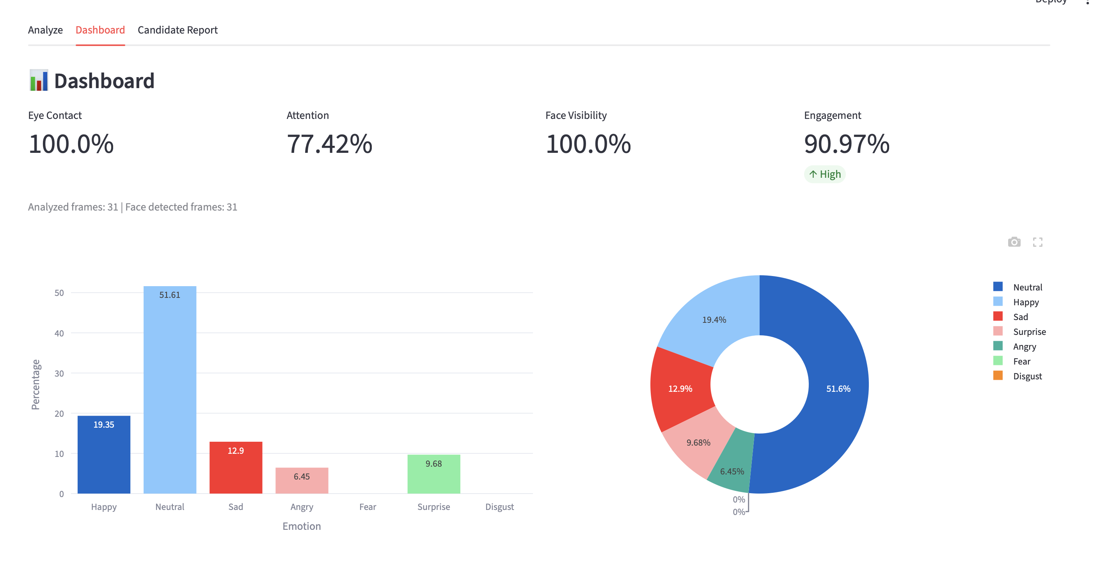

4.9 Live Interview Processing Module
The Live Interview Processing Module allows users to analyze their interview performance in real time using a webcam. This feature is implemented in the live_processor.py module together with streamlit-webrtc, which enables browser-based video streaming.
When the user starts a live interview session, the browser requests permission to access the webcam. After permission is granted, video frames are captured continuously and processed one by one.
Each live frame is passed to the Face Detection Module, where facial landmarks, facial blendshape scores, and the head transformation matrix are extracted. The system then performs emotion estimation, eye contact analysis, attention detection, and face visibility analysis in real time.
Unlike uploaded video analysis, the live module immediately overlays the analysis results on the camera feed, allowing users to monitor their performance while the interview is in progress.
When the interview ends, the collected frame-wise data is processed to calculate the final interview statistics and engagement score. A detailed interview report is then generated and made available for download.
The live interview feature enables users to practice interviews and receive immediate feedback without uploading any video files.

Functions Performed
- Accesses the webcam through the browser.
- Captures live video frames.
- Detects facial landmarks in real time.
- Estimates emotions continuously.
- Monitors eye contact and attention.
- Calculates the engagement score after the interview.
- Generates the final interview report.
Figure 4.5: Live Interview Processing
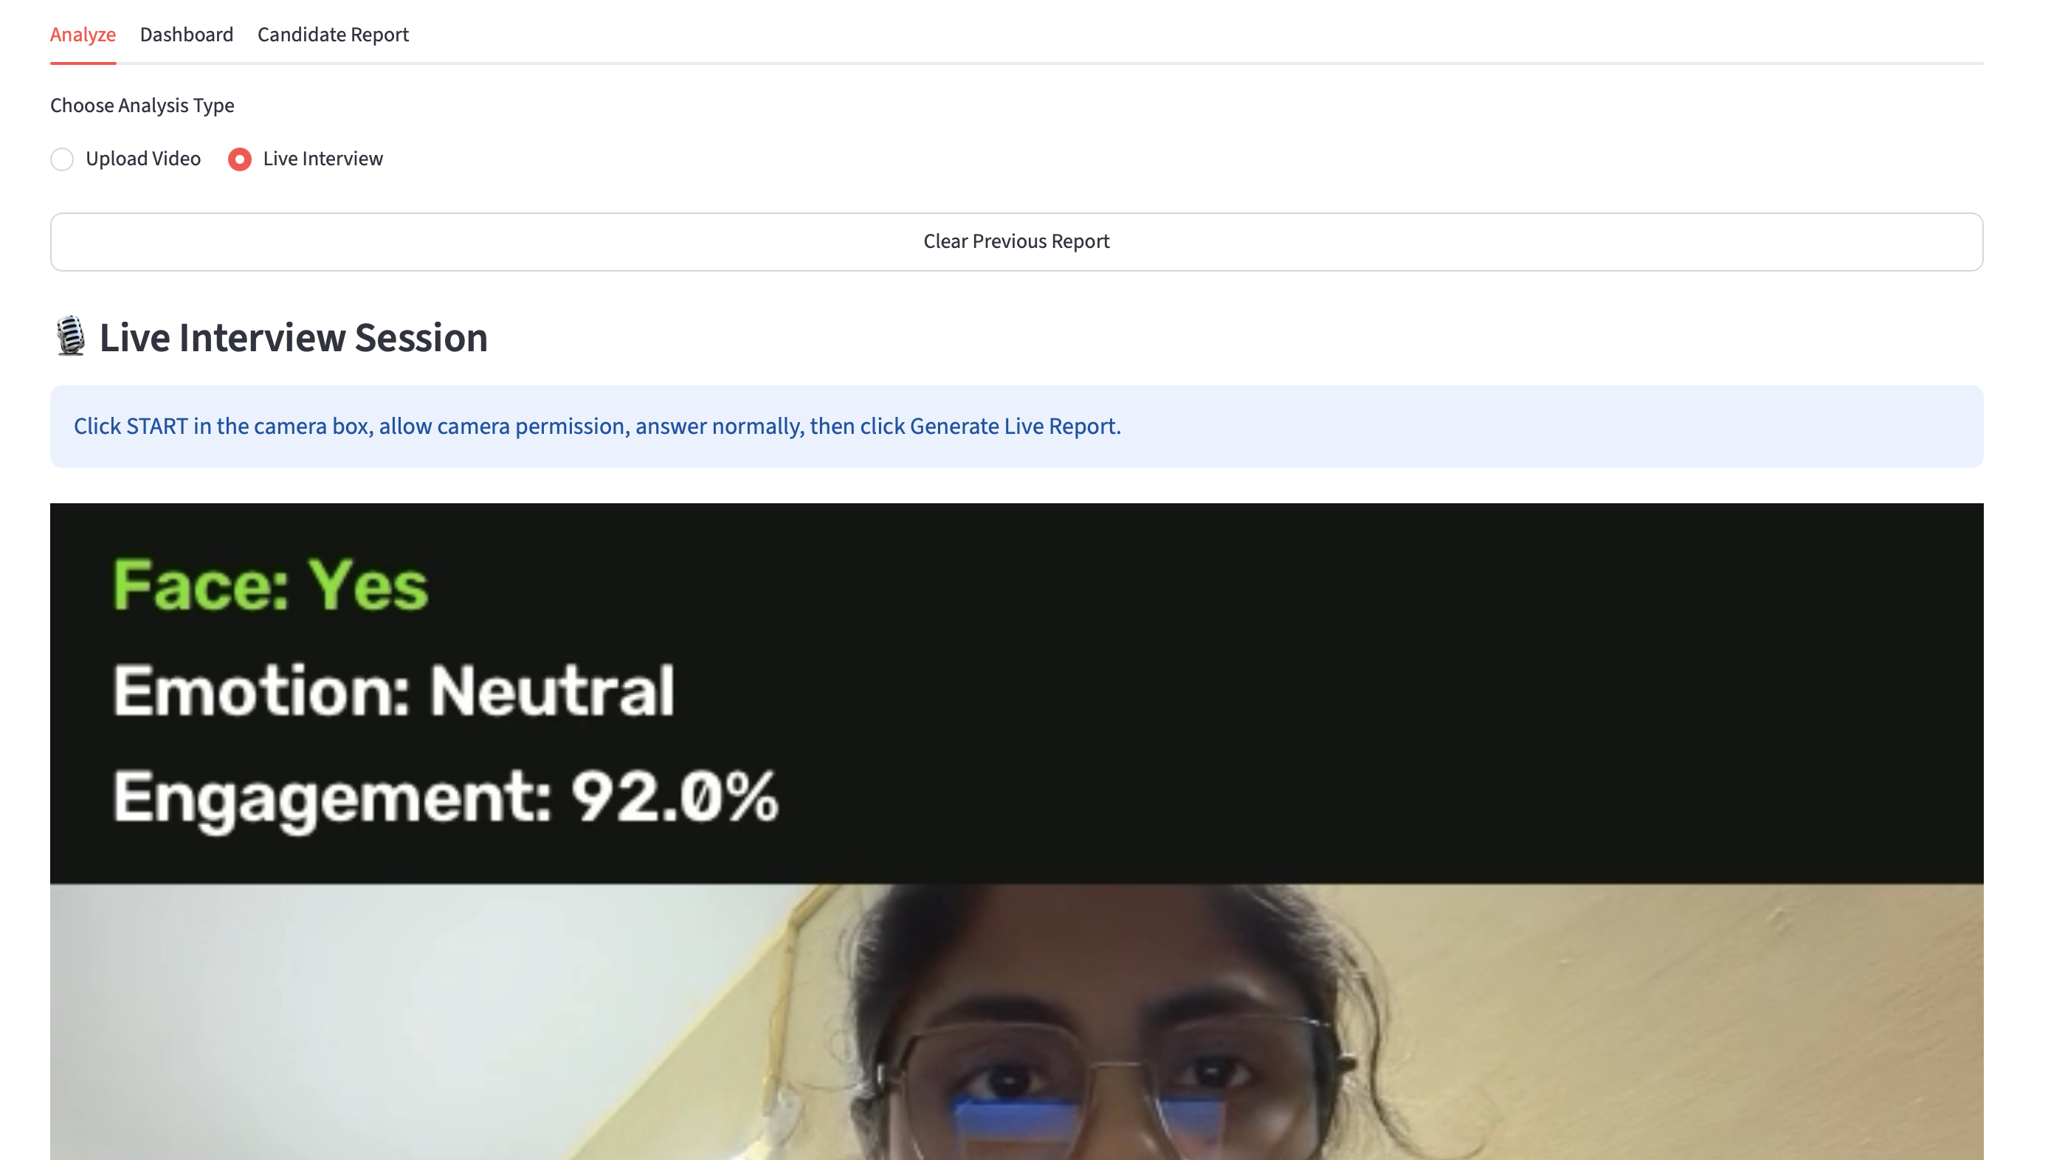

4.10 Streamlit User Interface
The Interview Analysis System provides a simple and interactive user interface developed using Streamlit. The interface is designed to make the application easy to use, even for users with little technical knowledge.
When the application starts, users are presented with two options: analyzing an uploaded interview video or starting a live interview session through the webcam. The interface guides the user through each step of the analysis process.
For uploaded videos, users can select a video file from their computer and click the Analyze Interview button. The application then processes the video and displays the results after the analysis is completed.
For live interviews, users can allow browser access to the webcam and begin the analysis in real time. The live video feed is displayed together with the analysis results.
After processing is completed, the dashboard displays important interview statistics, including:
- Emotion Distribution
- Eye Contact Score
- Attention Score
- Face Visibility Score
- Overall Engagement Score
- Interview Duration
- Candidate Performance Summary
The interface also provides an option to download the complete interview report in JSON format.The use of Streamlit makes the application lightweight, responsive, and easy to deploy without requiring complex frontend development.
Figure 4.6: Streamlit Home Screen
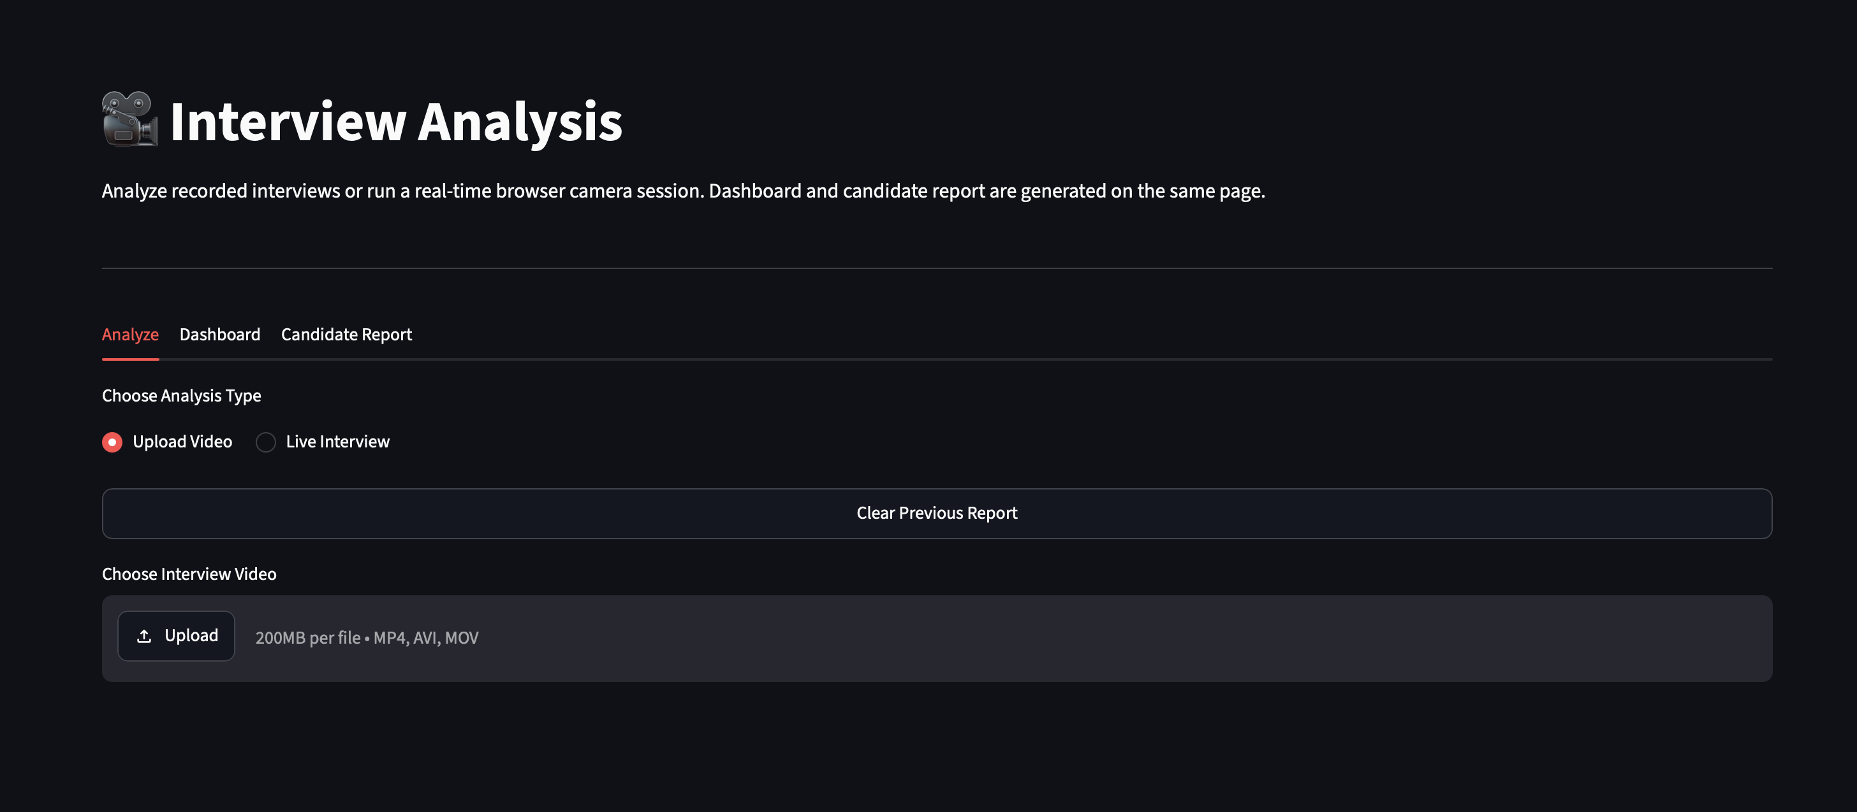

Figure 4.7: Interview Analysis Dashboard

(Insert a screenshot showing the final dashboard after analysis.)

4.11 Report Generation Module
After completing the interview analysis, the system automatically generates a detailed report summarizing the candidate's performance.
The report generation functionality is implemented in the report_generator.py module. This module collects all the analysis results generated during processing and organizes them into a structured JSON file.
The report contains important information such as:
- Interview duration
- Total processed frames
- Emotion distribution
- Eye Contact Score
- Attention Score
- Face Visibility Score
- Engagement Score
- Overall performance summary
The generated JSON report can be downloaded directly from the application and stored for future reference. Because JSON is a lightweight and widely supported format, the report can also be integrated easily with other software systems or databases.
The report provides candidates with detailed feedback about their interview performance and helps recruiters review interview statistics efficiently.
Figure 4.8: Generated JSON Report
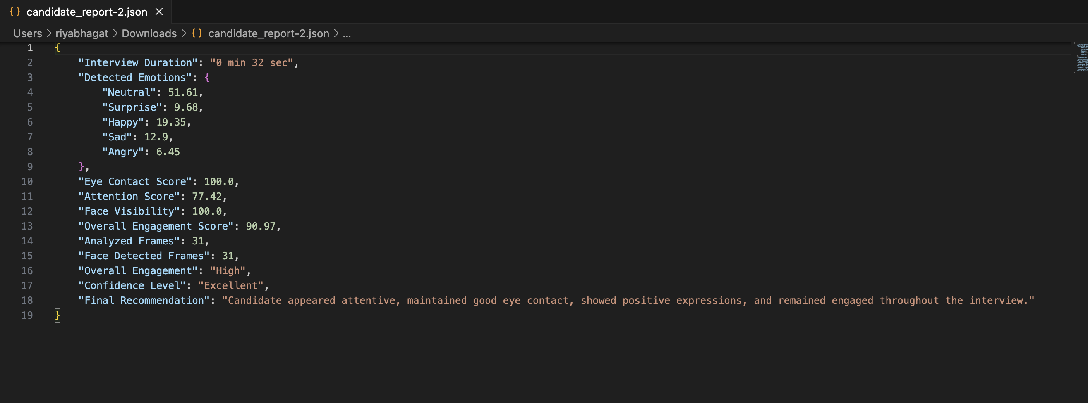

4.12 Testing and Results
After implementing all the modules, the application was tested using multiple interview videos as well as live webcam sessions. Different facial expressions, head movements, and eye contact patterns were observed to verify the working of the system.
The testing confirmed that the application successfully detects facial landmarks, estimates emotions, analyzes eye contact and attention, calculates engagement scores, and generates the interview report.
The dashboard correctly displays interview statistics using interactive charts, allowing users to understand their performance in a simple and visual manner.
The generated reports were verified to ensure that they contained all the required interview analysis details in the correct format.
Overall, the application performed reliably under normal lighting conditions and successfully analyzed both uploaded videos and live interview sessions.
Figure 4.9: Sample Analysis Result
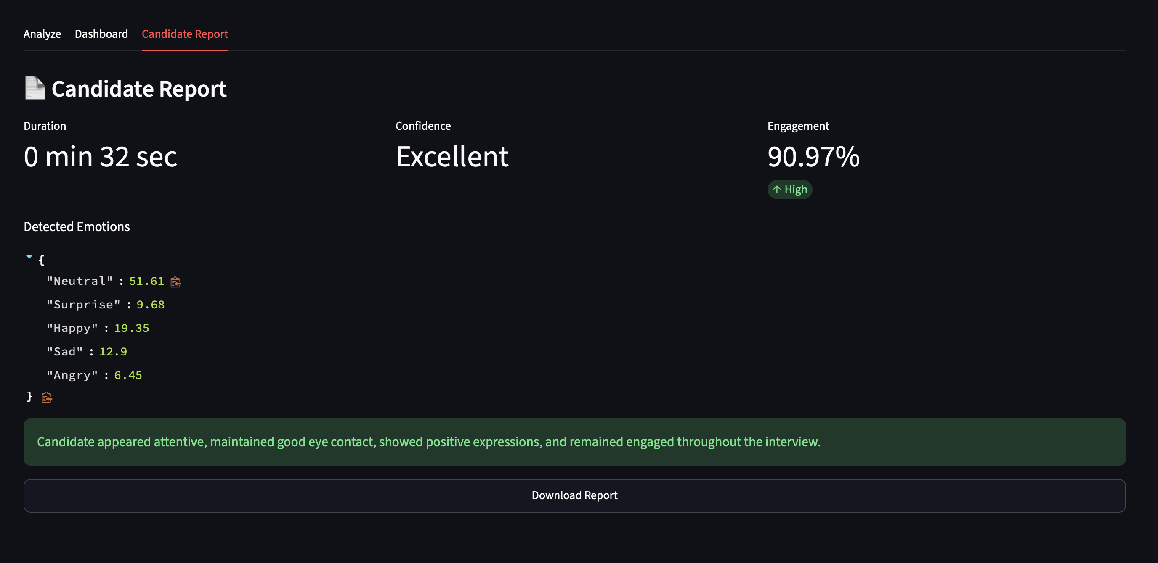

CHAPTER 5: RESULTS AND DISCUSSION

5.1 Introduction
This chapter presents the results obtained after testing the proposed Interview Analysis System Using Computer Vision and Facial Landmark Detection. The application was tested using both uploaded interview videos and live webcam sessions to evaluate its overall performance. The purpose of testing was to verify whether each module worked correctly and whether the system generated accurate interview analysis results.
The performance of the application was evaluated by observing different parameters such as face detection, emotion estimation, eye contact, attention level, face visibility, engagement score, and report generation. The results confirmed that the system performs the intended tasks successfully under normal operating conditions.

5.2 Experimental Testing
The application was tested using multiple interview videos containing different facial expressions, head movements, and eye contact patterns. Live interview sessions were also conducted using a webcam to verify the real-time analysis capability of the system.
The testing was performed under normal indoor lighting conditions with the candidate positioned directly in front of the camera. During testing, the following functionalities were verified:
- Video upload and processing
- Live webcam streaming
- Face detection using MediaPipe Face Landmarker
- Facial landmark extraction
- Emotion estimation
- Eye contact analysis
- Attention analysis
- Face visibility calculation
- Engagement score calculation
- JSON report generation
The successful execution of these modules confirmed that the complete workflow of the proposed system operates as expected.

5.3 Result Analysis
The results obtained during testing demonstrate that the application successfully performs interview analysis by combining multiple computer vision techniques.
The overall performance of the implemented modules is summarized in Table 5.1.

Table 5.1 Performance of System Modules
Module | Result
Video Processing | Successfully Processed
Face Detection | Successfully Detected
Facial Landmark Detection | Successful
Emotion Estimation | Successful
Eye Contact Analysis | Successful
Attention Detection | Successful
Face Visibility Analysis | Successful
Engagement Score Calculation | Successful
Dashboard Generation | Successful
JSON Report Generation | Successful

The generated dashboard displays the interview statistics in a simple graphical format, allowing users to understand their overall performance easily. The final report contains all the important behavioral parameters observed during the interview.

5.4 Discussion
The testing results indicate that the proposed system performs interview analysis efficiently and provides meaningful insights into a candidate's non-verbal behavior.
The Face Detection Module successfully detected faces in almost all frames under normal lighting conditions. Facial landmarks and blendshape values were extracted accurately, enabling the system to estimate facial emotions effectively.
The Eye Contact Module correctly identified whether the candidate was looking towards the camera, while the Attention Module accurately measured head orientation using the head transformation matrix. These observations helped calculate a reliable engagement score.
The generated dashboard allowed users to understand their interview performance through visual representations of different behavioral parameters. The downloadable JSON report summarized the complete interview analysis in a structured format, making it useful for future review.
Although the system performed well during testing, its performance may be affected when the face is partially covered, lighting conditions are poor, or the camera angle changes significantly. These situations can reduce the accuracy of face detection and behavioral analysis.

5.5 Performance Evaluation
The overall performance of the proposed system was found to be satisfactory during testing. The modular design enabled smooth communication between different components, resulting in efficient interview analysis.
Some important observations made during testing are listed below:
- The system successfully analyzed both uploaded interview videos and live webcam sessions.
- Face detection and facial landmark extraction were performed quickly and accurately.
- Emotion estimation worked effectively using MediaPipe facial blendshape scores.
- Eye contact and attention scores reflected the candidate's behavior throughout the interview.
- The engagement score provided an overall summary of interview performance.
- Interactive dashboards made the analysis easy to understand.
- The JSON report was generated successfully after every analysis session.
Overall, the proposed system achieved the project objectives and demonstrated the practical use of computer vision techniques in interview performance analysis.

CHAPTER 6: CONCLUSION AND FUTURE SCOPE

6.1 Conclusion
The Interview Analysis System Using Computer Vision and Facial Landmark Detection was developed to provide an automated approach for evaluating a candidate's non-verbal behavior during interviews. The system successfully analyzes both uploaded interview videos and live webcam sessions, making it suitable for interview practice as well as preliminary behavioral assessment.
The application uses MediaPipe Face Landmarker to detect facial landmarks, facial blendshape scores, and head transformation matrices. Based on these features, the system estimates facial emotions, eye contact, attention level, face visibility, and overall engagement. The analyzed results are presented through an interactive dashboard, and a detailed interview report is generated in JSON format.
During testing, all the major modules of the application performed successfully. The system accurately processed interview videos, detected faces, estimated behavioral parameters, calculated engagement scores, and generated reports. The modular architecture made the application easy to develop, maintain, and extend.
The project demonstrates that computer vision can be effectively used to automate the analysis of non-verbal communication during interviews. It reduces the dependency on manual observation and provides candidates with useful feedback that can help them improve their interview performance. Overall, the proposed system successfully achieved the objectives defined at the beginning of the project.

6.2 Limitations
Although the proposed system performs well under normal conditions, it has some limitations.
- The accuracy of face detection may decrease under poor lighting conditions.
- The system performs best when the candidate's face is clearly visible to the camera.
- Sudden head movements or partial face occlusion may affect attention and eye contact analysis.
- The project focuses only on visual behavioral analysis and does not evaluate spoken answers or communication skills.
- The generated report is currently available only in JSON format.
- The system analyzes one candidate at a time and does not support multiple users simultaneously.
These limitations provide opportunities for further improvements in future versions of the application.

6.3 Future Scope
The proposed system can be enhanced by adding several advanced features to improve its capabilities and make it more useful for interview preparation and recruitment.
Some possible future enhancements are listed below:
- Integrate speech and voice analysis to evaluate communication skills, confidence, and speaking pace.
- Add automatic speech-to-text transcription for analyzing interview responses.
- Implement question-wise performance evaluation to provide detailed feedback for each interview question.
- Store interview reports in a database for long-term record management and comparison.
- Provide an option to export reports in PDF format in addition to JSON.
- Develop an admin dashboard to manage and compare reports of multiple candidates.
- Improve emotion estimation using advanced deep learning models trained on larger facial expression datasets.
- Add cheating and distraction detection to identify mobile phone usage, multiple faces, or frequent off-screen movements during online interviews.
- Integrate cloud storage to securely save interview reports and analysis results.
- Develop a mobile version of the application for easier accessibility.
Implementing these features will make the system more intelligent, accurate, and suitable for real-world recruitment and interview training applications.

6.4 Overall Summary
The Interview Analysis System successfully combines computer vision techniques with an easy-to-use web interface to automate interview performance analysis. By evaluating facial emotions, eye contact, attention, face visibility, and engagement, the system provides valuable insights into a candidate's non-verbal communication.
The project demonstrates the practical application of facial landmark detection in solving real-world problems and provides a strong foundation for future research and development in AI-based interview assessment systems.

BIBLIOGRAPHY
- OpenCV, Open Source Computer Vision Library. Available: https://opencv.org/
- Google AI, MediaPipe Face Landmarker Documentation. Available: https://ai.google.dev/edge/mediapipe
- Streamlit Inc., Streamlit Documentation. Available: https://docs.streamlit.io/
- Plotly Technologies Inc., Plotly Python Documentation. Available: https://plotly.com/python/
- Pandas Development Team, Pandas Documentation. Available: https://pandas.pydata.org/docs/
- Python Software Foundation, Python 3 Documentation. Available: https://docs.python.org/3/
- OpenCV Contributors, OpenCV-Python Tutorials. Available: https://docs.opencv.org/
- GitHub, MediaPipe GitHub Repository. Available: https://github.com/google-ai-edge/mediapipe
- Bradski, G., and Kaehler, A., Learning OpenCV: Computer Vision with the OpenCV Library. O'Reilly Media, 2008.
- Szeliski, R., Computer Vision: Algorithms and Applications, 2nd Edition, Springer, 2022.
- Bishop, C. M., Pattern Recognition and Machine Learning. Springer, 2006.
- Goodfellow, I., Bengio, Y., and Courville, A., Deep Learning. MIT Press, 2016.
- Reitz, K., and Schlusser, T., The Hitchhiker's Guide to Python. O'Reilly Media, 2016.
- Hunter, J. D., "Matplotlib: A 2D Graphics Environment," Computing in Science & Engineering, Vol. 9, No. 3, pp. 90–95, 2007.
- Official Git Documentation. Available: https://git-scm.com/doc

APPENDIX
The appendix contains supporting material related to the implementation of the Interview Analysis System.

Appendix A – Software Requirements
- Python 3.x
- Streamlit
- OpenCV
- MediaPipe
- streamlit-webrtc
- Plotly
- Pandas
- NumPy
- Visual Studio Code
- Git

Appendix B – Hardware Requirements

Minimum Requirements
- Processor: Intel Core i3 or equivalent
- RAM: 4 GB
- Storage: 500 MB free space
- Webcam
- Internet connection (for package installation)

Recommended Requirements
- Processor: Intel Core i5/i7 or Apple M-series
- RAM: 8 GB or above
- SSD Storage
- HD Webcam

Appendix C – Sample Output
The appendix also includes sample outputs generated by the application, including:
- Home Page
- Upload Interview Screen
- Live Interview Screen
- Dashboard
- Emotion Distribution Graph
- Engagement Score
- Generated JSON Report

